 | 7.1.13 Editors - 3D Viewport - Header - Mesh - Edit mode - UV menu
Table of content
Detailed Table of content 1
Edit Mode - UV Menu 4
Angle Based 4
Conformal 4
Minimum Stretch 4
Smart UV Project 6
Lightmap Pack 7
Follow Active Quads 7
Cube Projection 7
Project from View 9
Project from View (Bounds) 10
Mark Seam 10
Clear Seam 10
Reset 11

Detailed Table of content

Detailed table of content
Detailed Table of content 1
Edit Mode - UV Menu 4
Angle Based 4
Conformal 4
Minimum Stretch 4
Last Operator Unwrap 4
Method 4
Method Angle based + Conformal 4
Method 4
Fill Holes 4
Use Subdivision Surface 5
Correct Aspect 5
Margin Method 5
Scaled 5
Add 5
Fraction 5
Margin 5
Method Minimum Stretch 5
Iterations 5
No Flip 5
Importance Weight 5
Use Subdivision Surface 5
Correct Aspect 5
Margin Method 5
Scaled 5
Add 5
Fraction 5
Margin 5
Smart UV Project 6
Smart UV Project Settings dialogue 6
Angle Limit 6
Margin Method 6
Scaled 6
Add 6
Fraction 6
Rotation Method 6
Island Margin 6
Area Weight 6
Correct Aspect 6
Last Operator Smart UV Project 6
Lightmap Pack 7
Settings 7
Selection 7
Share Tex Space 7
New UV Map 7
Pack Quality 7
Margin 7
Follow Active Quads 7
Settings 7
Edge Length Mode 7
Last Operator Follow Active Quads 7
Cube Projection 7
Last Operator Cube Projection 8
Cube Size 8
Correct Aspect 8
Clip to Bounds 8
Scale to Bounds 8
Cylinder Projection 8
Last Operator Cylinder Projection 8
Direction 8
Align 8
Pole 8
Preserve Seams 8
Radius 8
Correct Aspect 8
Clip to Bounds 9
Scale to Bounds 9
Sphere Projection 9
Last Operator Sphere Projection 9
Direction 9
Align 9
Pole 9
Preserve Seams 9
Correct Aspect 9
Clip to Bounds 9
Scale to Bounds 9
Project from View 9
Last Operator Project from View 10
Orthographic 10
Camera Bounds 10
Correct Aspect 10
Clip to Bounds 10
Scale to Bounds 10
Project from View (Bounds) 10
Mark Seam 10
Clear Seam 10
Reset 11

Edit Mode - UV Menu

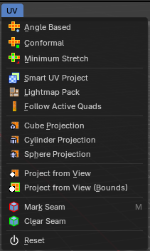
Here you find the uv mapping methods and some further functionality. You use it best in the U Editing layout. There you can see the result in the UV Editor then.

The UV menu is just available for Mesh objects.

Angle Based
Unwraps the selected geometry with the method Angle based. ABF stands for Angle Based Flattening. ABF can give a bit better result than LSCM when unwrapping organic shapes.

Conformal
Unwraps the selected geometry with the method LSCM, which is the short for Least Square Conformal Mapping. LSCM can give a bit better results than ABF with geometric shapes.

Minimum Stretch
Unwraps the selected geometry with the method SLIM, which is a “state-of-the-art” iterative UV unwrapping algorithm.

Last Operator Unwrap

Method
Method is a drop down box where you can choose the unwrap method.

Method Angle based + Conformal
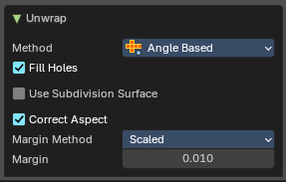
Unwrap ABF and Unwrap LSCM shares the same Last Operator.

Method
Method is a drop down box where you can choose between Unwrap method Angle Based and Conformal.

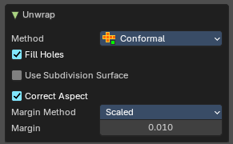
Fill Holes
Fill holes in the mesh before unwrapping.

Use Subdivision Surface
Unwraps an existing Subdivision Modifier. You need to add a Subdivision Modifier first.

Correct Aspect
Take the Image Aspect Ratio into account.

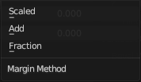
Margin Method

Scaled
Use the scale of existing UV to multiply margin.

Add
Just add the margin and ignore any existing UV.

Fraction
Specify a precise fraction of specific UV.

Margin
The distance between the single UV patches.

Method Minimum Stretch
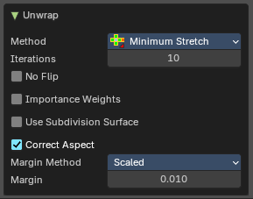

Iterations
Number of iterations.

No Flip
Prevent flipping UV's

Importance Weight
Take per vertex importance weights into account.

Use Subdivision Surface
Unwraps an existing Subdivision Modifier. You need to add a Subdivision Modifier first.

Correct Aspect
Take the Image Aspect Ratio into account.

Margin Method

Scaled
Use the scale of existing UV to multiply margin.

Add
Just add the margin and ignore any existing UV.

Fraction
Specify a precise fraction of specific UV.

Margin
The distance between the single UV patches.

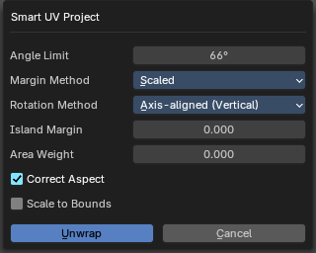
Smart UV Project
Smart UV Project projects the UV mapping from different angles.

Smart UV Project Settings dialogue

Angle Limit
The Angle Limit defines after which angle the mapping happens from the next side. With an angle of 66 you have around six sides to map from. The calculation is 360/66.

Margin Method

Scaled
Use the scale of existing UV to multiply margin.

Add
Just add the margin and ignore any existing UV.

Fraction
Specify a precise fraction of specific UV.

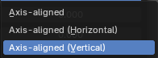
Rotation Method
How to rotate islands.

Island Margin
Island Margin defines the distance between the UV patches.

Area Weight
Weight Projection Vector by faces with larger areas.

Correct Aspect
Take the Image Aspect Ratio into account.

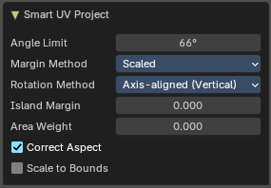
Last Operator Smart UV Project
The Last Operator for Smart UV Project contains the same settings than the Smart UV Project Settings dialogue.

Lightmap Pack
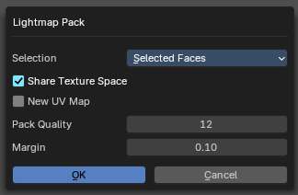
Lightmap Pack maps each face individually, and puts the result into the UV space. Without margin.
Lightmap Pack has no Last Operator.

Settings

Selection
Selection is a drop-down box where you can choose what will be packed, either Selected Faces or All Faces.

Share Tex Space
Map all objects into one lightmap.

New UV Map
Create a new UV map for every new mesh.

Pack Quality
The pack quality.

Margin
The distance between the single UV patches.

Follow Active Quads
Follow Active quads maps UV coordinates starting from an active face, and maps all adjacent faces in quad shape then. This way you can for example unwrap a pipe or a road. You first need to have a face selected. Then select everything. And then click at Follow Active Quads.

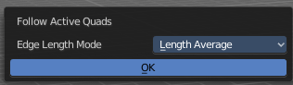
Settings

Edge Length Mode
Edge Length Mode is a drop-down box where you can choose the Length method.

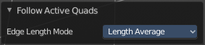
Last Operator Follow Active Quads
The Last Operator contains the same settings than the Settings dialogue.

Cube Projection
Cube Projection maps the mesh from six sides, means cubic.

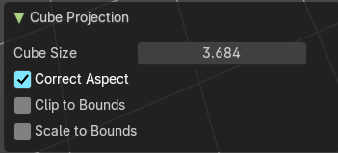
Last Operator Cube Projection

Cube Size
Cube Size defines the size of the UV mesh in the UV space.

Correct Aspect
Take Image Aspect ratio into account.

Clip to Bounds
Clip UV Coordinates to bounds after unwrapping.

Scale to Bounds
Scale UV Coordinates to bounds after unwrapping.

Cylinder Projection
Cylinder Projection tries to map the geometry cylindric.

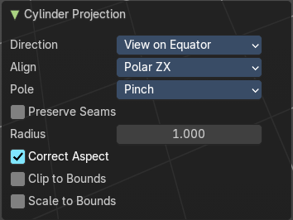
Last Operator Cylinder Projection

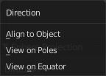
Direction
Direction is a drop-down box where you can choose in which direction the spherical projection will be mapped.

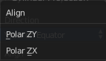
Align
Align is a drop-down box where you can choose the Align method.

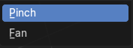
Pole
How to handle the faces at the poles.

Preserve Seams
Keep existing seams intact.

Radius
Radius defines the Polar size of the UV mesh in the UV space.

Correct Aspect
Take Image Aspect ratio into account.

Clip to Bounds
Clip UV Coordinates to bounds after unwrapping.

Scale to Bounds
Scale UV Coordinates to bounds after unwrapping.

Sphere Projection
Sphere Projection tries to map the geometry spherical.

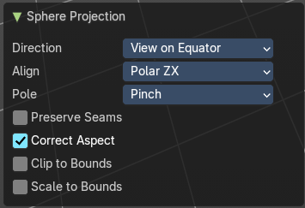
Last Operator Sphere Projection

Direction
Direction is a drop-down box where you can choose in which direction the spherical projection will be mapped.

Align
Align is a drop-down box where you can choose the Align method.

Pole
How to handle the faces at the poles.

Preserve Seams
Keep existing seams intact.

Correct Aspect
Take Image Aspect ratio into account.

Clip to Bounds
Clip UV Coordinates to bounds after unwrapping.

Scale to Bounds
Scale UV Coordinates to bounds after unwrapping.

Project from View
Project from View projects the UV from the current 3D view.

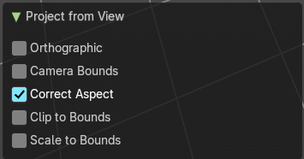
Last Operator Project from View

Orthographic
User orthographic projection.

Camera Bounds
Map UV's to the camera region taking resolution and aspect into account.

Correct Aspect
Take Image Aspect ratio into account.

Clip to Bounds
Clip UV Coordinates to bounds after unwrapping.

Scale to Bounds
Scale UV Coordinates to bounds after unwrapping.

Project from View (Bounds)
Project from View projects the UV from the current 3D view.
Same as Project from View, but with Scale to Bounds ticked in the Last operator. And so it scales to the bounds.

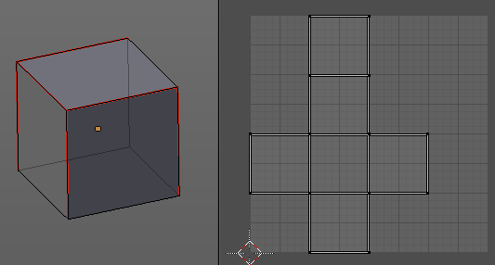
Mark Seam
The unwrap algorithms Angle based and Conformal requires to have edges marked as seams. Think of it as a cutting pattern for a trouser for example. Such a trouser is also made of fabric patterns.
Same goes for the UV patches when you use Angle based or conformal unwrapping. You need to cut your mesh into parts and mark edges as seams, so that the algorithm knows where the seams are.
Mark seam marks the currently selected edge(s) as a seam. Seam edges will be displayed as red in the 3D viewport.

Clear Seam
Clear seam removes the seam from the currently selected edge(s).

Reset
Resets the UV Projection.

